**Project report template**

**1.Introduction :**

1.1 Overview:

The improved features of CRM software have increased both is complexity and necessity. Nearly half of CRM implementation campaigns suffer from improper preparation and misaligned objectives among internal stakeholders.

1.2 Purpose:

It is saved a lot of time. The purpose of the project is to manage the school students result tracking process in the easy way. Students do not need to check the notice board and everyone will stay updated.

**2.Problem definition & design thinking:** 2.1 empathy map: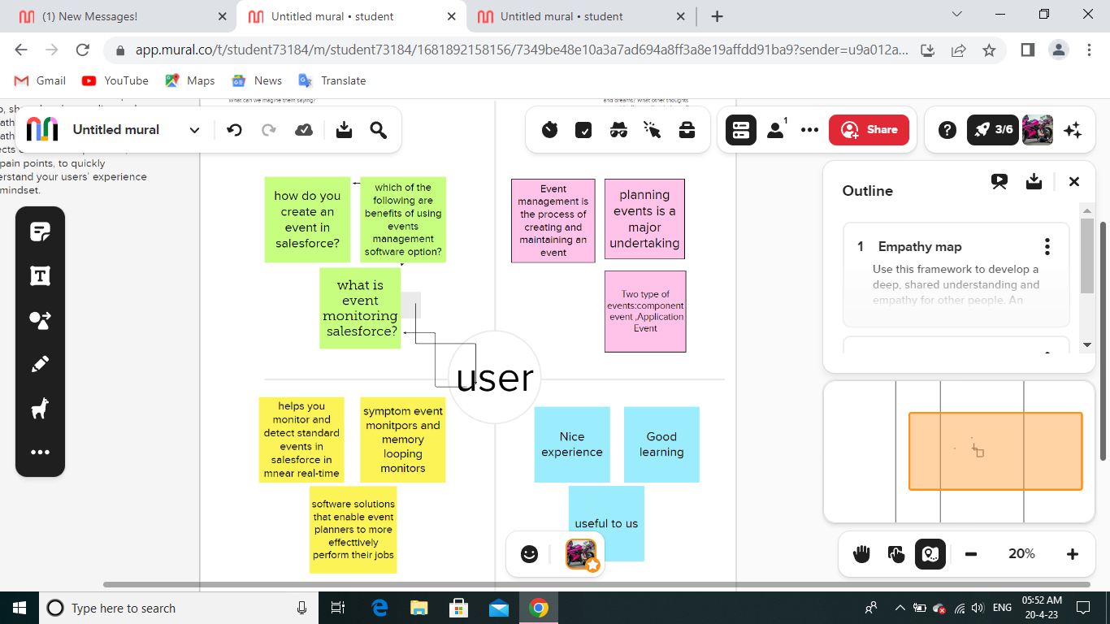

2.2 Ideation & brainstorming map: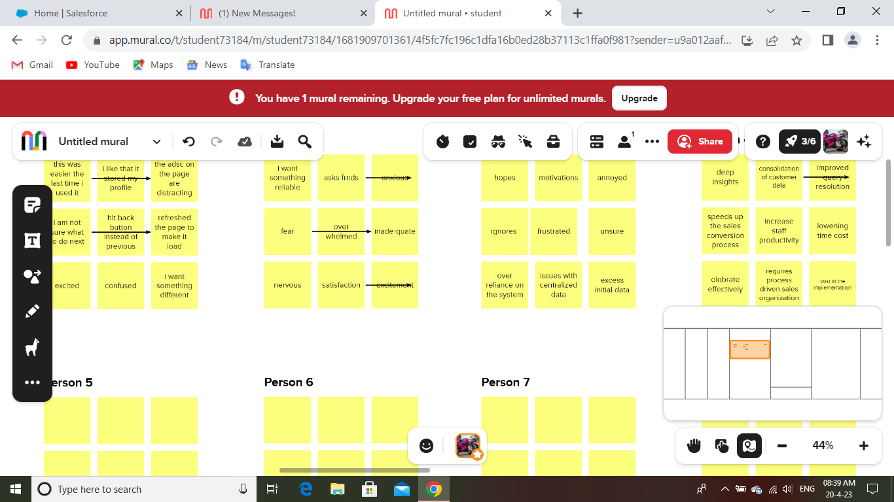

**3.Result :**

**3.1 Data model :**

|  |  |  |  |
| --- | --- | --- | --- |
| **Object name** | **Fields in the object**   |  |  | | --- | --- | | Field label | Data type | |

|  |  |  |
| --- | --- | --- |
| semester | semesters | Text |
| Candidate | Candidates | Text |
| Course detail | Course details | Text |
| Lecture detail | Lecture details | Text |
| Internal detail | Internal details | Text |

**3.2 Activity & screenshot**

**Creating developer account :**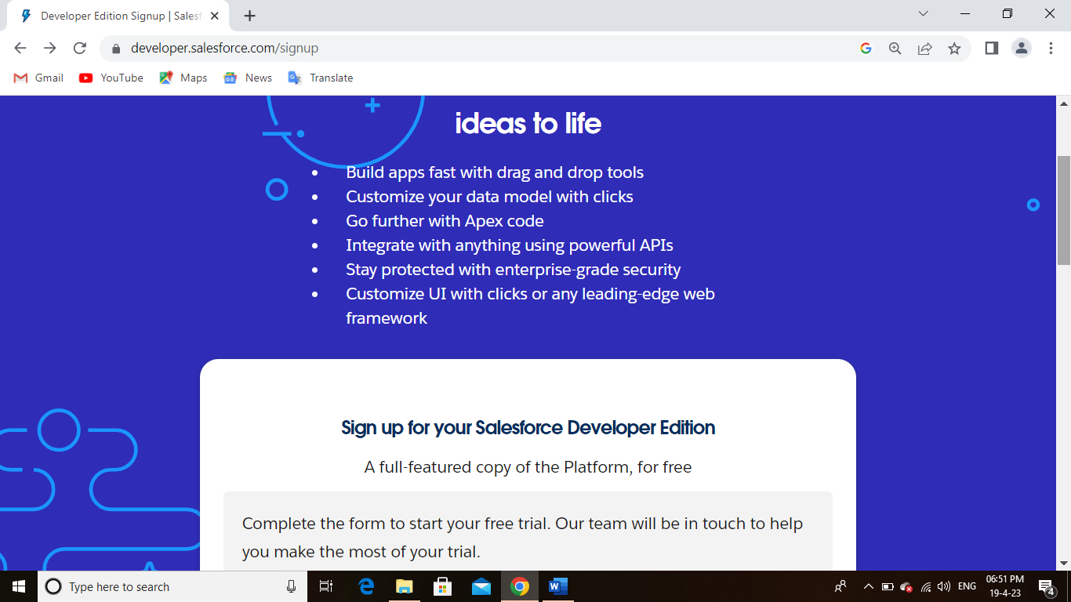

**Sales force login :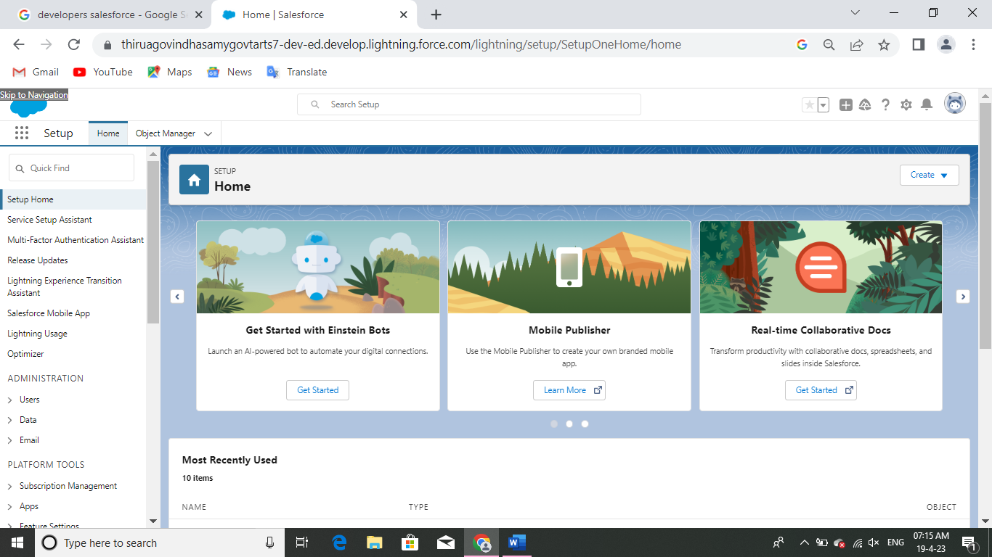Objects :**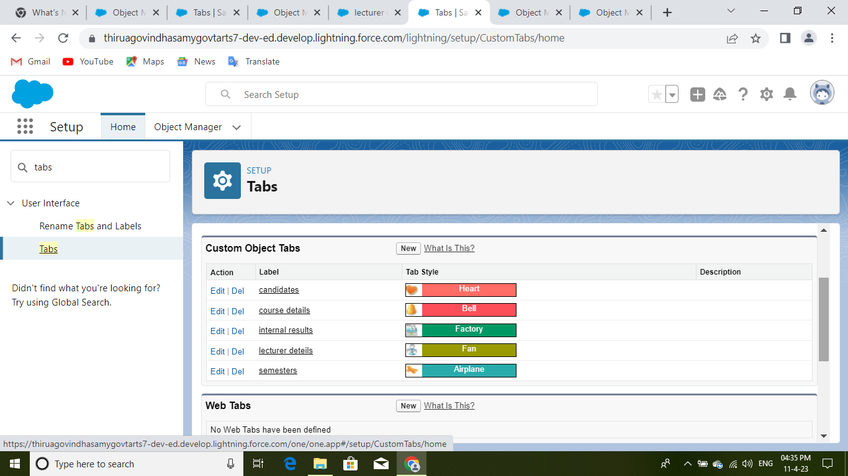

**Fields and relationships:**

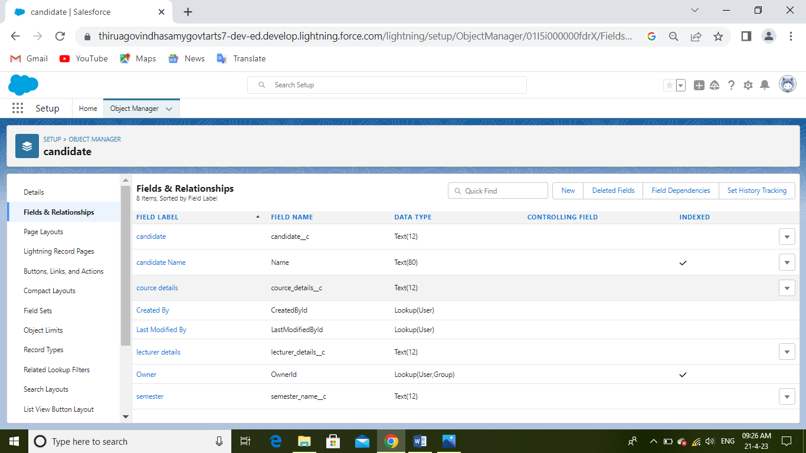**Lightning app :**

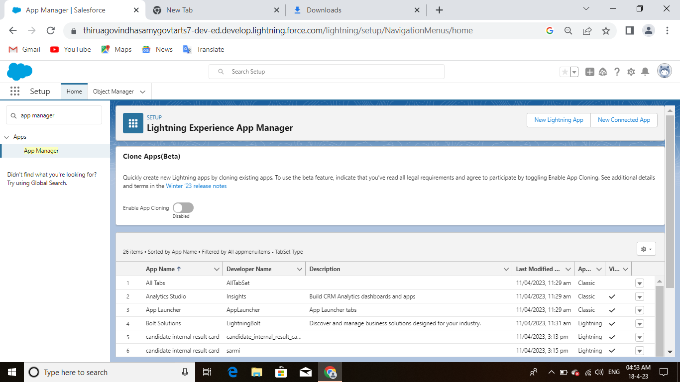

**Users :**

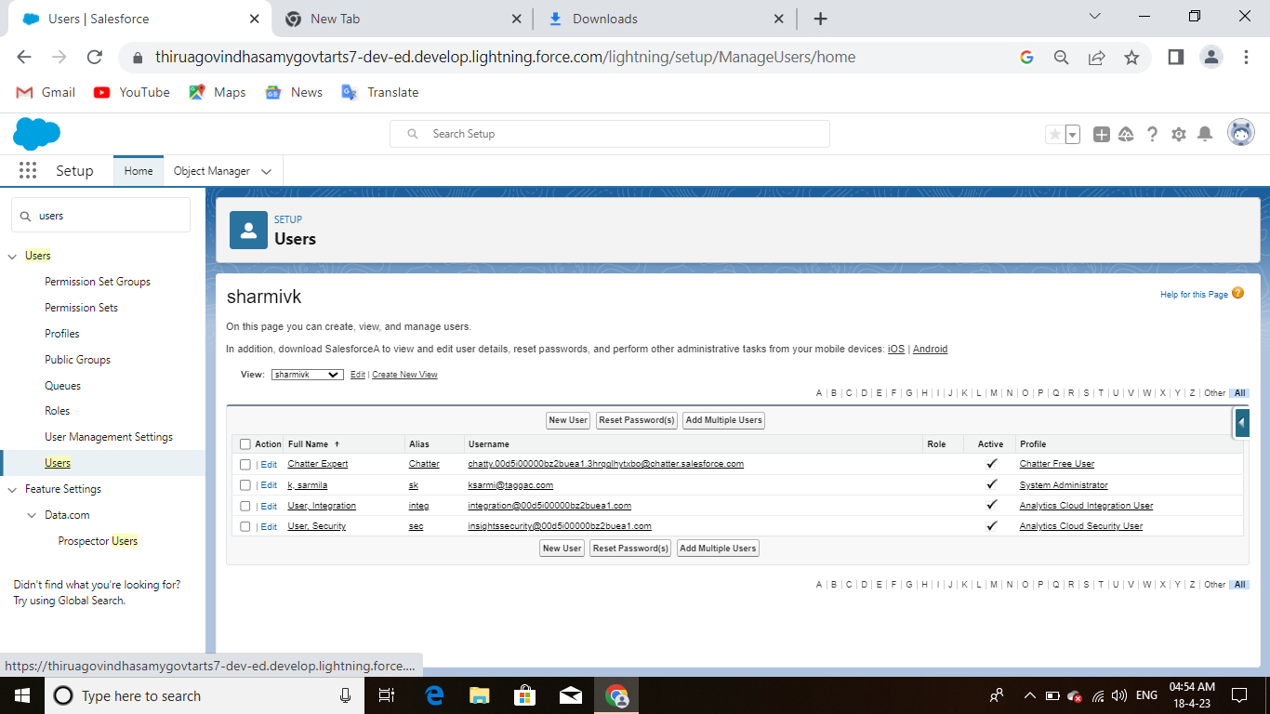

**Reports :**

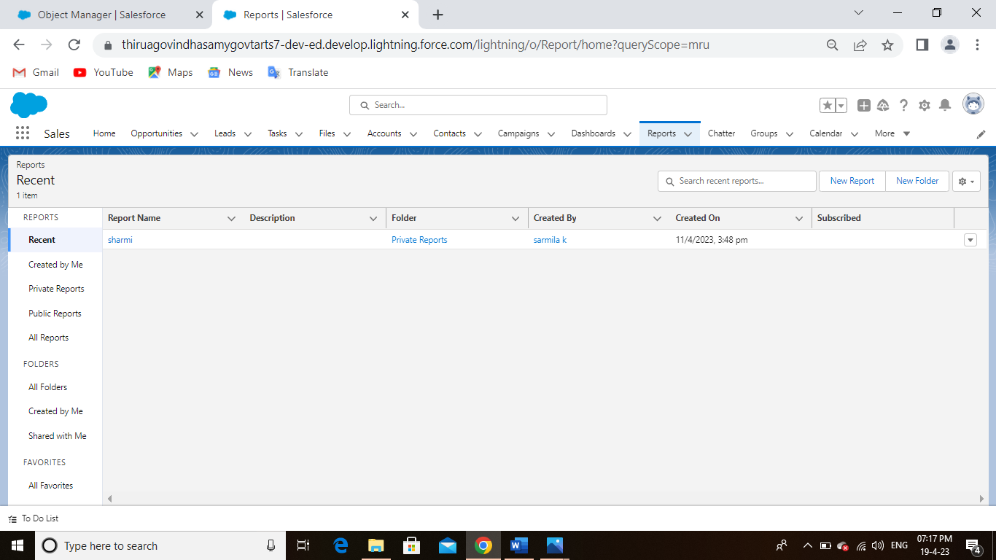

**Dashboards :**

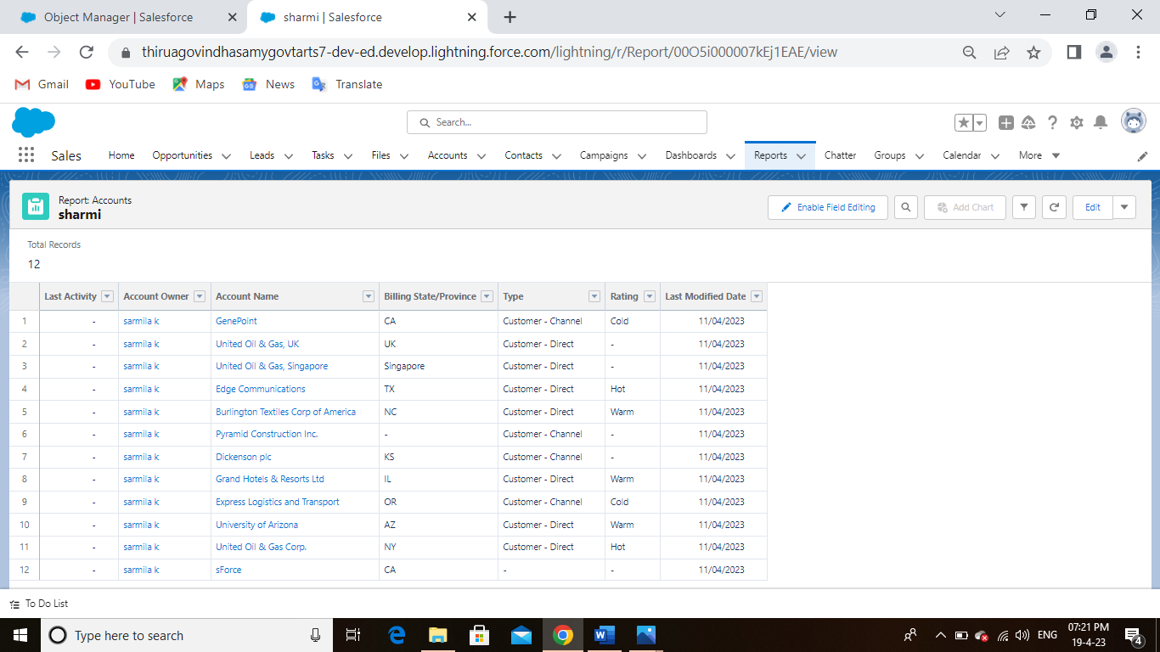

**4.Trailhead profile public URL**

Team lead - https://trailblazer.me/id/ksharmila5

Team members 1: https://trailblazer.me/id/spavi39

Team members 2: https://trailblazer.me/id/sounn4

Team members 3: https://trailblazer.me/id/sugar49

**5.Advantages & disadvantage:**

Advantage:

* It allows for the consolidation of customer data and the basis for deep insights
* It speeds up sales conversion project
* It increases staff productivity, lowering time-cost
* It allows geographically dispersed team to collaborate effectively

Disadvantage:

* Customer experience may worsen due to staff over-reliance on the system
* Security and data prodection issues with contralized data
* The excess initial time and productivity cost at the implementation
* Requires a process-driven sales organization

**6.Applications :**

* I want something reliable
* Target marketing
* Incease candidate quality
* Can work easily

**7.Conclusion:**

Student internal mark management system deals with student details, academic related reports, collage detail and course details it tracks all the details of a student from the day one to the end of his course which can be used for all reporting purpose.

**8.Future scope:**

Scope of the education means range of view, outlook, field or opportunity of activity ,operation and application of education has a wider meaning and application .